## PROJECT DEVELOPMENT PHASE DELIVERY OF SPRINT-2

|  |  |
| --- | --- |
| Team ID | PNT2022TMID32509 |
| Project Name | Retail Store Stock Inventory Analytics |

**PROJECT DEVELOPMENT PHASE:**

**Sprint-1:**

**Sprint-2:**

* Data Collection
* Data Preparation
* Data Exploration

**Sprint-3:**

**Sprint-4:**

* Dashboard Creation
  + Report Creation
  + Story Creation

# SPRINT-2:

### DATA EXPLORATION

* LOAD THE DATASET
* SALES ANALYSIS
* PRICE ANALYSIS
* STOCK AND PRICE FOR YEAR COLORED BY PRICE
* PRICE FOR YEAR COLORED BY YEAR
* STOCK AND SALES FOR YEAR COLORED BY YEAR
* YEAR COLORED BY YEAR SIZED BY STOCK
* STOCK TREE SUNBURST
* SALES TO PRICE WITH LINE WIDTH PRICE
* STOCK USERS
* YEAR SIZED BY SALES
* PREPARED DATA LINK

# DATA COLLECTION:

Download the Dataset

Dataset link - https://rb.gy/mepmp0

**LOAD THE DATASET:**

Tool used – IBM Cognos

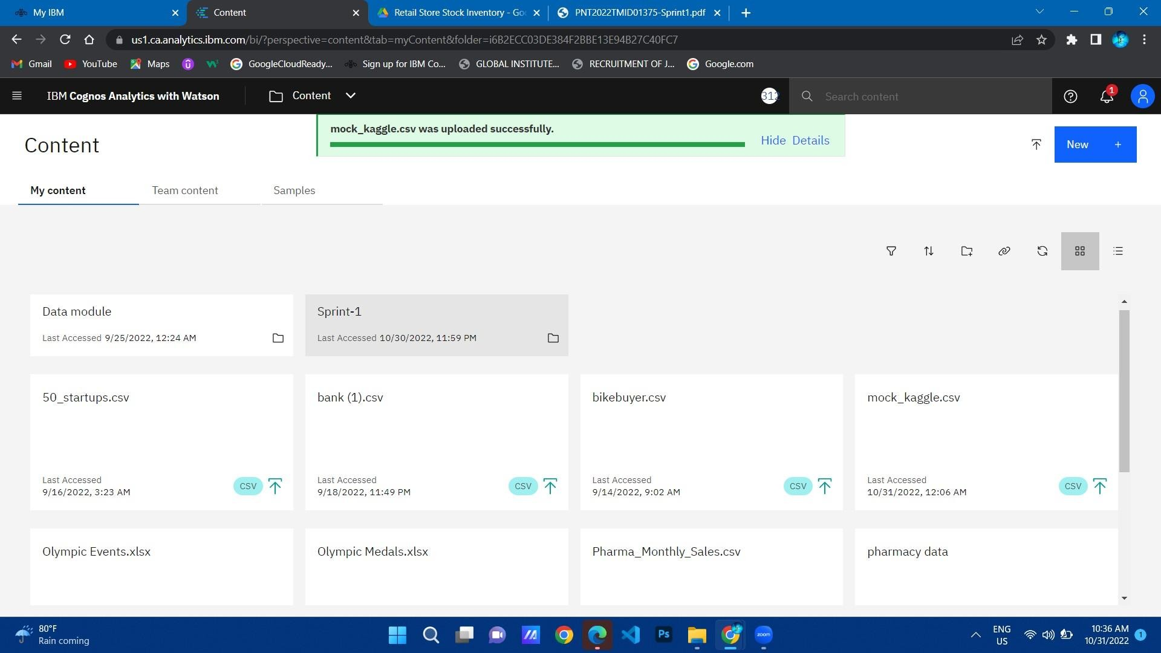

SALES ANALYSIS:

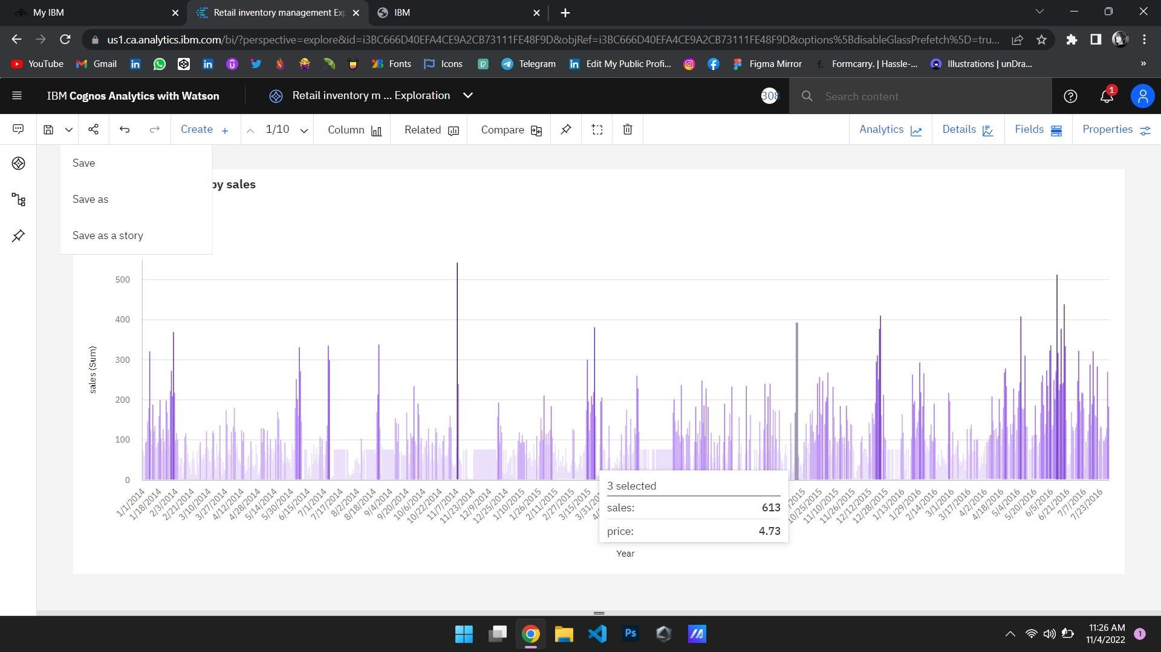

**PRICE ANALYSIS:**

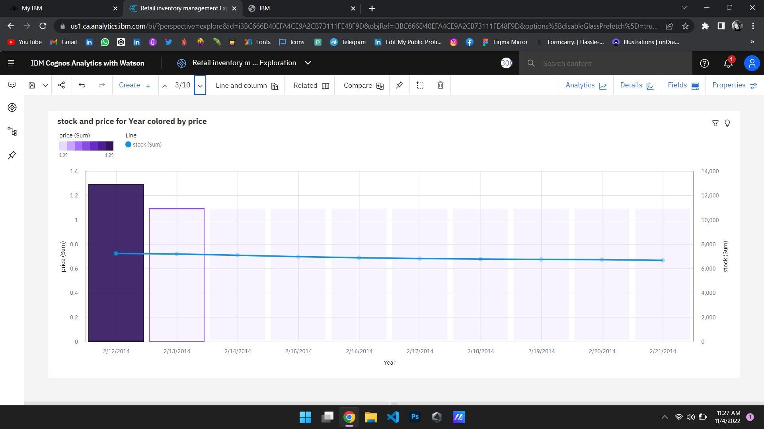

**STOCK AND PRICE FOR YEAR COLORED BY PRICE:**

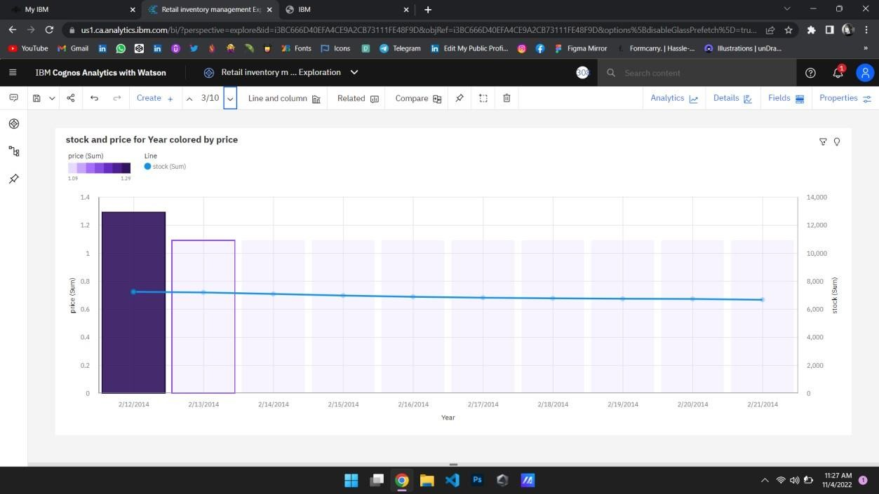

## PRICE FOR YEAR COLORED BY YEAR:

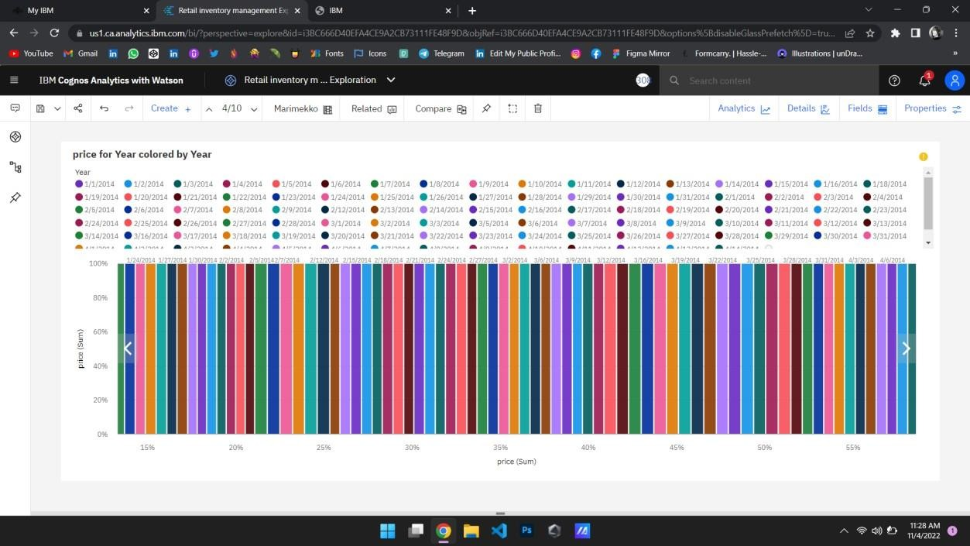

**STOCK AND SALES FOR YEAR COLORED BY YEAR:**

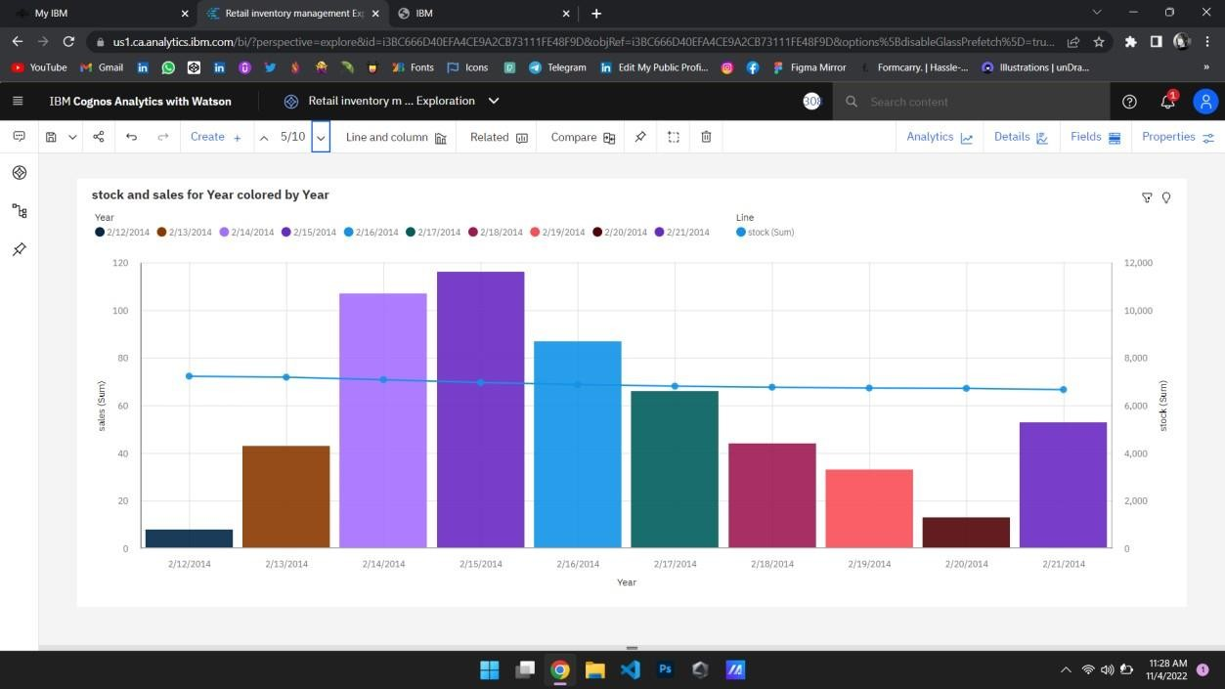

## YEAR COLORED BY YEAR SIZED BY STOCK:

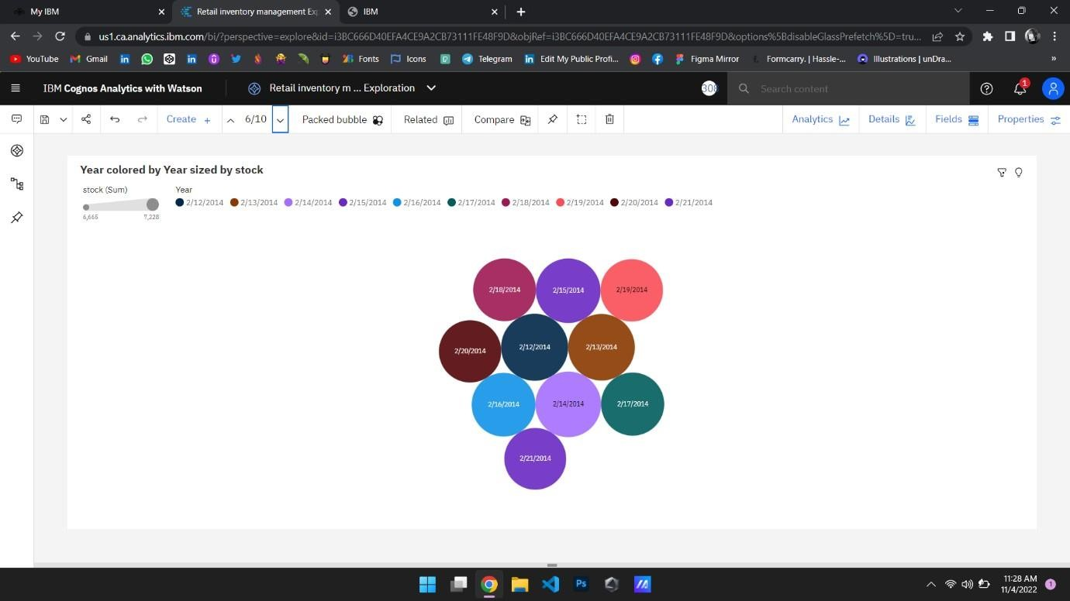

**STOCK TREE SUNBURST:**

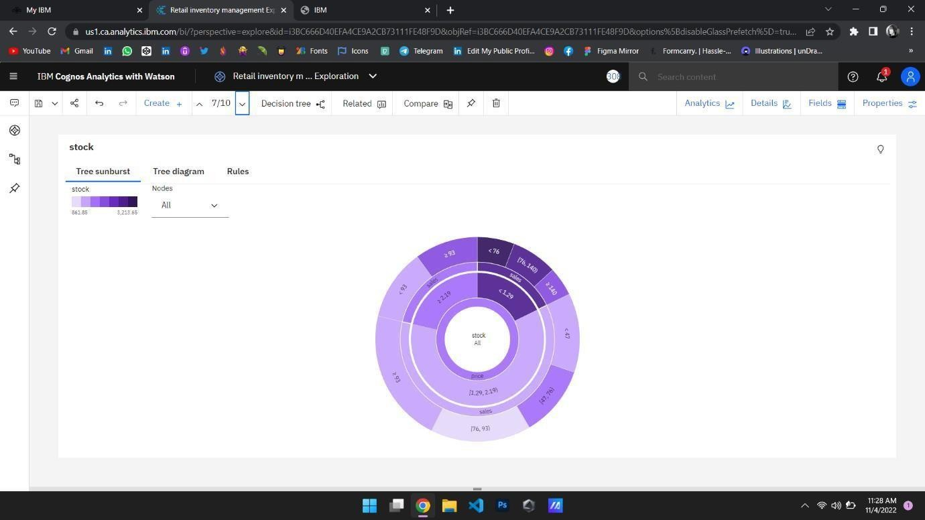

# SALES TO PRICE WITH LINE WIDTH PRICE:

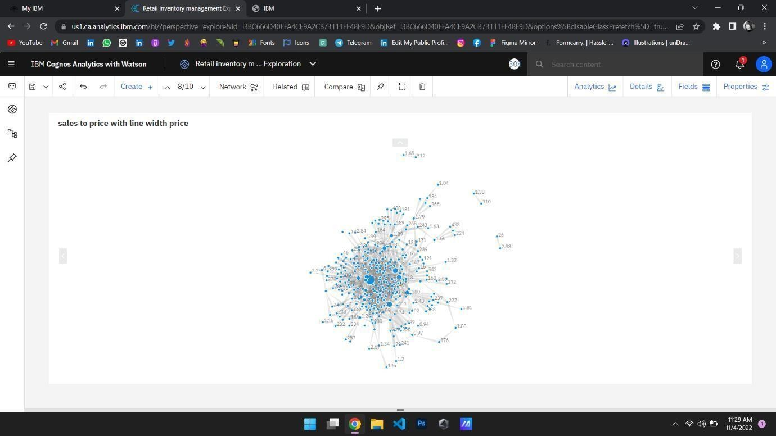

**STOCK USERS:**

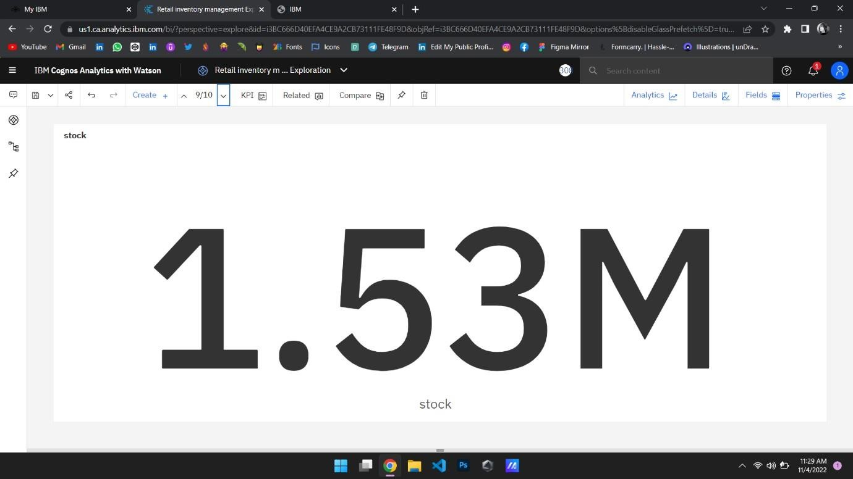

## YEAR SIZED BY SALES:

